Independent Health Complaints Advocacy Service
Client consent form – why we need your consent ☐ ☐

To allow us to support you with your complaint we need signed permission from
• you,
• the patient, where you are complaining on behalf of another person.

This will allow us to
• act on your behalf,
• receive all relevant information about the complaint.

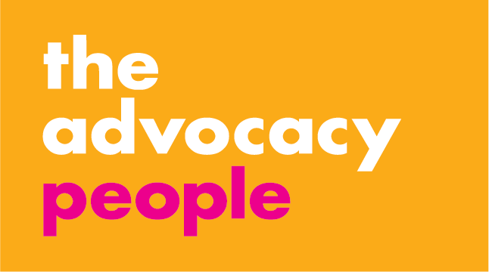
All communications between you and Advocacy for Bromley will remain confidential unless:
• you tell us something which leads us to believe you or someone else may be at risk of serious harm or abuse, or assisting a serious criminal offence.
• there is a court order for disclosure.

By requesting advocacy support, you give consent to The Advocacy People sharing information, as required for the purposes of providing the service. For more information on our Privacy Policy, please ask your advocate or go to: advocacyforbromley.org/privacyseap

1 Personal Details

Name

Address
Postcode

Date of Birth

2 Are you making the complaint for…

yourself ? – go to Section 7

someone else? – go to Section 3

3 Patient Details (if applicable)

The patient must consent to the complaint or be incapable of giving consent

Name

Date of Birth

4 Your relationship to patient

5 Is the patient capable of giving consent?

No - please specify (e.g. deceased, lacks
mental capacity etc.) and go to Section 7

Yes - go to Section 6

6 Patient consent
Signature
Date of consent

7 Complainant consent
Signature
Date of consent

By signing, the patient/complainant authorises us to:
• act on your behalf
• receive all relevant information
• ask others to deal with your advocate as though with yourself
8 Your Contact Details

Telephone Number:

Mobile Number:

E-mail Address:

9 Equality and Diversity - Complainant

Gender

☐ Female
☐ Male
☐ Transgender (male to female)
☐ Transgender (female to male)
☐ Other

☐ Prefer not to say

Ethnicity
☐ Arab
☐ Asian or Asian British - Bangladeshi
☐ Asian or Asian British - Chinese
☐ Asian or Asian British - Indian
☐ Asian or Asian British - Pakistani
☐ Asian or Asian British - Other

☐ Black or Black British - African
☐ Black or Black British – Carribean
☐ Black or Black British - Other

☐ Mixed - White and Asian
☐ Mixed - White and Black African
☐ Mixed - White and Black Carribean
☐ Mixed - Other

☐ White British
☐ White Gypsy or Irish Traveller
☐ White Irish
☐ White - Other
☐ Other ethnic group

☐ Prefer not to say

Sexual Orientation
☐ Bisexual
☐ Gay Man
☐ Heterosexual
☐ Lesbian
☐ Questioning
☐ Other

☐ Prefer not to say

Marital or Civil Partnership Status

☐ In Civil Partnership
☐ Co-habiting
☐ Divorced or Civil Partnership Dissolved
☐ Married
☐ Separated (but still legally married / in Civil P.)
☐ Single
☐ Surviving partner of Civil Partnership
☐ Widowed
☐ Prefer not to say

Military Connection

☐ Yes, Serving
☐ Yes, Veteran
☐ Yes, Carer relationship
☐ No
☐ Prefer not to say

Disability

☐ Not considered to have a disability
☐ Acquired Brain Injury
☐ Autism Spectrum Condition
☐ Cognitive Impairment
☐ Dementia / Alzheimer’s
☐ Learning Disability
☐ Mental Health Problem
☐ Physical Disability
☐ Sensory (Hearing)
☐ Sensory (Sight)
☐ Serious Physical Illness
☐ Unconsciousness
☐ Other

☐ Prefer not to say

Religion
☐ Buddhist
☐ Christian (all denominations)
☐ Hindu
☐ Jewish
☐ Muslim
☐ Sikh
☐ No Religion
☐ Other

☐ Prefer not to say

Please return this form
By post: Advocacy for Bromley,
P.O. Box 375, Hastings TN34 9HU
By e-mail: info@theadvocacypeople.org.uk

(You must scan the signed form before e-mailing

