Independent Health Complaints Advocacy Service
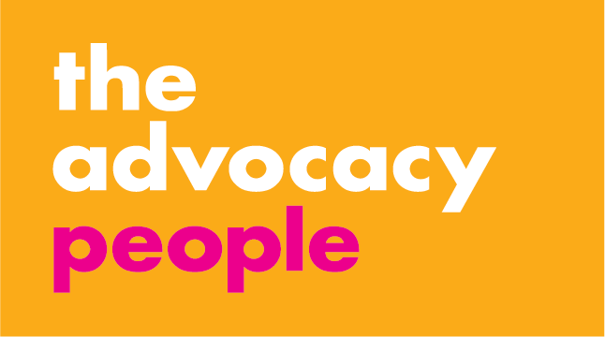
Please complete and return to Advocacy for Bromley, P.O. Box 375, Hastings TN34 9HU
Email: info@theadvocacypeople.org.uk

If you have any questions or would like assistance in completing the form,
please call our Contact Centre on 0300 343 5728

Your name:

If you are complaining on behalf of someone else, please give their name:

Your relationship to them:

Is this person happy for you to contact us on their behalf? Yes No Not applicable
Name of the GP:
GP Address:
Your address:
Postcode:
Your home telephone number:

Your mobile telephone number:

Your email address:

What is the best way to contact you?

Please tell us something about the issue or incident you are complaining about. It would be helpful to know when and where the incident happened and the name/s of those involved.

How did this affect you / the person who you are making the complaint on behalf of?

Have you raised this complaint elsewhere already? Yes No
If so, with whom and what was the response?

Do you have any relevant paperwork regarding your complaint?

Please enclose any copies which you think may help us to support you.
What do you wish to achieve by making this complaint?

Action to put things right
Answers to specific questions
An apology
Changes to services
An explanation
Other – please state

We would like to know how you feel at the moment about raising your concerns with the NHS.

Once your complaint has reached an end we hope we can ask the same questions to measure the effectiveness of our work and to find out how useful you have found our advocacy services.

Please complete the table below:

When dealing with the NHS, I feel.…
1
Never 2
Rarely 3
Sometimes 4
Mostly / Always
Listened to
Informed
Treated with respect
Confident to speak up
In control of decisions

